Project 2 Documentation

Part 1: HIVE USECASE

First thing Run Hive Local VR:

Terminal Command: Hive

A screenshot of a cell phone

Description generated with very high confidence

Then we create the database called hero:

Terminal Command: CREATE DATABASE hero;

A close up of a logo

Description generated with very high confidence

Then use hero database :

Terminal Command: USE hero;

A screenshot of a cell phone

Description generated with high confidence

Then create table superheros :

Terminal Command: CREATE TABLE superheros (id INT, name STRING, gender STRING, eye_color STRING, race STRING, hair_color STRING, height FLOAT, publisher STRING, skin_color STRING, alignment STRING, weight FLOAT ) ROW FORMAT DELIMITED FIELDS TERMINATED BY ',';

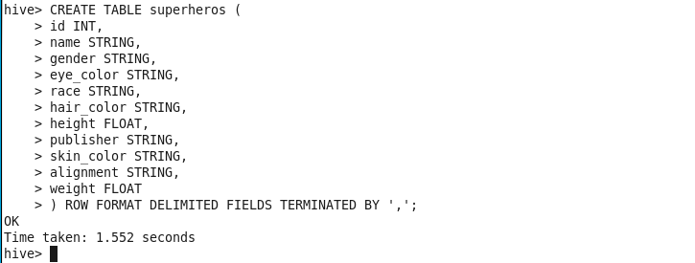

To see the table use this code:

Terminal Command: DESCRIBE superheros;

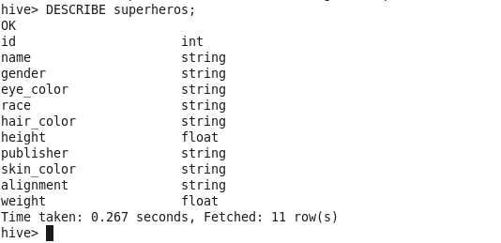

Then load the data from local host:

Terminal Command: LOAD DATA LOCAL INPATH '/home/cloudera/Desktop/Lab2/Heros' INTO TABLE superheros;

A screenshot of a cell phone

Description generated with very high confidence

To see the data enter this code:

Select * from superheros;

A screenshot of a cell phone

Description generated with high confidence

For the assignment we had to create Complex Data Types, we use struct for all the colors and size, this is why we create the superheros2 table:

Terminal Command: CREATE TABLE superheros2 ( id INT, name STRING, gender STRING, race STRING, color struct< hair:STRING, eye:STRING, skin:STRING>, size struct< height:FLOAT, weight:FLOAT>, publisher STRING, alignment STRING ) ROW FORMAT DELIMITED FIELDS TERMINATED BY '\t' collection items terminated by ',';

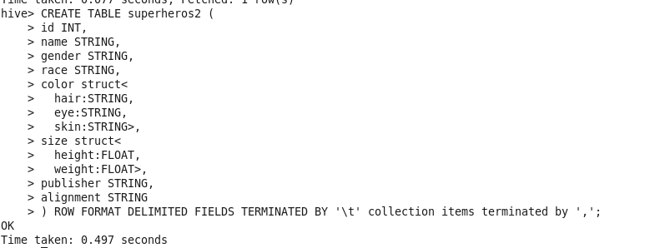

To see the superheros2 file use this:

Terminal Command: DESCRIBE superheros2;

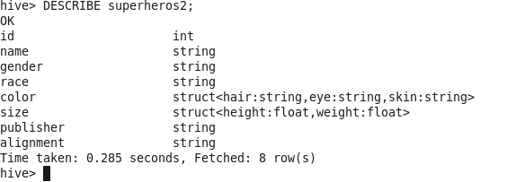

After we done loading the Super Hero tables then we have to load the Super Powers:

Terminal Command: CREATE TABLE superpowers ( hero_names STRING, `Agility` BOOLEAN, `Accelerated Healing` BOOLEAN, `Lantern Power Ring` BOOLEAN, `Dimensional Awareness` BOOLEAN, `Cold Resistance` BOOLEAN, `Durability` BOOLEAN, `Stealth` BOOLEAN, `Energy Absorption` BOOLEAN, `Flight` BOOLEAN, `Danger Sense` BOOLEAN, `Underwater breathing` BOOLEAN, `Marksmanship` BOOLEAN, `Weapons Master` BOOLEAN, `Power Augmentation` BOOLEAN, `Animal Attributes` BOOLEAN, `Longevity` BOOLEAN, `Intelligence` BOOLEAN, `Super Strength` BOOLEAN, `Cryokinesis` BOOLEAN, `Telepathy` BOOLEAN, `Energy Armor` BOOLEAN, `Energy Blasts` BOOLEAN, `Duplication` BOOLEAN, `Size Changing` BOOLEAN, `Density Control` BOOLEAN, `Stamina` BOOLEAN, `Astral Travel` BOOLEAN, `Audio Control` BOOLEAN, `Dexterity` BOOLEAN, `Omnitrix` BOOLEAN, `Super Speed` BOOLEAN, `Possession` BOOLEAN, `Animal Oriented Powers` BOOLEAN, `Weapon-based Powers` BOOLEAN, `Electrokinesis` BOOLEAN, `Darkforce Manipulation` BOOLEAN, `Death Touch` BOOLEAN, `Teleportation` BOOLEAN, `Enhanced Senses` BOOLEAN, `Telekinesis` BOOLEAN, `Energy Beams` BOOLEAN, `Magic` BOOLEAN, `Hyperkinesis` BOOLEAN, `Jump` BOOLEAN, `Clairvoyance` BOOLEAN, `Dimensional Travel` BOOLEAN, `Power Sense` BOOLEAN, `Shapeshifting` BOOLEAN, `Peak Human Condition` BOOLEAN, `Immortality` BOOLEAN, `Camouflage` BOOLEAN, `Element Control` BOOLEAN, `Phasing` BOOLEAN, `Astral Projection` BOOLEAN, `Electrical Transport` BOOLEAN, `Fire Control` BOOLEAN, `Projection` BOOLEAN, `Summoning` BOOLEAN, `Enhanced Memory` BOOLEAN, `Reflexes` BOOLEAN, `Invulnerability` BOOLEAN, `Energy Constructs` BOOLEAN, `Force Fields` BOOLEAN, `Self-Sustenance` BOOLEAN, `Anti-Gravity` BOOLEAN, `Empathy` BOOLEAN, `Power Nullifier` BOOLEAN, `Radiation Control` BOOLEAN, `Psionic Powers` BOOLEAN, `Elasticity` BOOLEAN, `Substance Secretion` BOOLEAN, `Elemental Transmogrification` BOOLEAN, `Technopath/Cyberpath` BOOLEAN, `Photographic Reflexes` BOOLEAN, `Seismic Power` BOOLEAN, `Animation` BOOLEAN, `Precognition` BOOLEAN, `Mind Control` BOOLEAN, `Fire Resistance` BOOLEAN, `Power Absorption` BOOLEAN, `Enhanced Hearing` BOOLEAN, `Nova Force` BOOLEAN, `Insanity` BOOLEAN, `Hypnokinesis` BOOLEAN, `Animal Control` BOOLEAN, `Natural Armor` BOOLEAN, `Intangibility` BOOLEAN, `Enhanced Sight` BOOLEAN, `Molecular Manipulation` BOOLEAN, `Heat Generation` BOOLEAN, `Adaptation` BOOLEAN, `Gliding` BOOLEAN, `Power Suit` BOOLEAN, `Mind Blast` BOOLEAN, `Probability Manipulation` BOOLEAN, `Gravity Control` BOOLEAN, `Regeneration` BOOLEAN, `Light Control` BOOLEAN, `Echolocation` BOOLEAN, `Levitation` BOOLEAN, `Toxin and Disease Control` BOOLEAN, `Banish` BOOLEAN, `Energy Manipulation` BOOLEAN, `Heat Resistance` BOOLEAN, `Natural Weapons` BOOLEAN, `Time Travel` BOOLEAN, `Enhanced Smell` BOOLEAN, `Illusions` BOOLEAN, `Thirstokinesis` BOOLEAN, `Hair Manipulation` BOOLEAN, `Illumination` BOOLEAN, `Omnipotent` BOOLEAN, `Cloaking` BOOLEAN, `Changing Armor` BOOLEAN, `Power Cosmic` BOOLEAN, `Biokinesis` BOOLEAN, `Water Control` BOOLEAN, `Radiation Immunity` BOOLEAN, `Vision - Telescopic` BOOLEAN, `Toxin and Disease Resistance` BOOLEAN, `Spatial Awareness` BOOLEAN, `Energy Resistance` BOOLEAN, `Telepathy Resistance` BOOLEAN, `Molecular Combustion` BOOLEAN, `Omnilingualism` BOOLEAN, `Portal Creation` BOOLEAN, `Magnetism` BOOLEAN, `Mind Control Resistance` BOOLEAN, `Plant Control` BOOLEAN, `Sonar` BOOLEAN, `Sonic Scream` BOOLEAN, `Time Manipulation` BOOLEAN, `Enhanced Touch` BOOLEAN, `Magic Resistance` BOOLEAN, `Invisibility` BOOLEAN, `Sub-Mariner` BOOLEAN,`Radiation Absorption` BOOLEAN, `Intuitive aptitude` BOOLEAN, `Vision - Microscopic` BOOLEAN,`Melting` BOOLEAN, `Wind Control` BOOLEAN, `Super Breath` BOOLEAN, `Wallcrawling` BOOLEAN,`Vision - Night` BOOLEAN, `Vision - Infrared` BOOLEAN, `Grim Reaping` BOOLEAN, `Matter Absorption` BOOLEAN, `The Force` BOOLEAN, `Resurrection` BOOLEAN, `Terrakinesis` BOOLEAN, `Vision - Heat` BOOLEAN, `Vitakinesis` BOOLEAN, `Radar Sense` BOOLEAN, `Qwardian Power Ring` BOOLEAN,`Weather Control` BOOLEAN, `Vision - X-Ray` BOOLEAN, `Vision - Thermal` BOOLEAN,`Web Creation` BOOLEAN, `Reality Warping` BOOLEAN, `Odin Force` BOOLEAN, `Symbiote Costume` BOOLEAN, `Speed Force` BOOLEAN, `Phoenix Force` BOOLEAN, `Molecular Dissipation` BOOLEAN, `Vision - Cryo` BOOLEAN,`Omnipresent` BOOLEAN,`Omniscient` BOOLEAN ) ROW FORMAT DELIMITED FIELDS TERMINATED BY ',';

A screenshot of a cell phone

Description generated with very high confidence

To see the superhero table :

Terminal Command: DESCRIBE superpowers ;

A screenshot of a cell phone

Description generated with very high confidence

Then load the data to the superpowers table;

Terminal Command: LOAD DATA LOCAL INPATH '/home/cloudera/Desktop/Lab2/Powers' INTO TABLE superpowers;

A screenshot of a cell phone

Description generated with very high confidence

To see the table:

Terminal Command: Select * from superpowers;

A screenshot of a cell phone

Description generated with high confidence

We had to use more then one complex data types, because of this we used array on the superpower table : because of this we create superpower2 table;

Terminal Command: CREATE TABLE superpowers2 ( name STRING, powers Array<STRING> ) ROW FORMAT DELIMITED FIELDS TERMINATED BY '\t' collection items terminated by ',';



To see the table :

Terminal Command: DESCRIBE superpowers2;

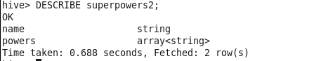

After creating the complex data types we have to enter the data to thus tables, first enter data to the superheros2:

Terminal Command: INSERT INTO TABLE superheros2 SELECT id, name, gender, race, named_struct( 'hair',hair_color, 'eye',eye_color, 'skin',skin_color ) as color, named_struct( 'height', height, 'weight', weight ) as size, publisher, alignment FROM superheros;

A screenshot of a cell phone

Description generated with very high confidence

Then we insert the superpower2:

Terminal Command: INSERT INTO TABLE superpowers2 SELECT name, collect_set(power) powers FROM (SELECT hero_names name, t2.key power FROM superpowers LATERAL VIEW explode (map( 'Agility', `Agility`, 'Accelerated Healing', `Accelerated Healing`, 'Lantern Power Ring', `Lantern Power Ring`, 'Dimensional Awareness', `Dimensional Awareness`, 'Cold Resistance', `Cold Resistance`, 'Durability', `Durability`, 'Stealth', `Stealth`, 'Energy Absorption', `Energy Absorption`, 'Flight', `Flight`, 'Danger Sense', `Danger Sense`, 'Underwater breathing', `Underwater breathing`, 'Marksmanship', `Marksmanship`, 'Weapons Master', `Weapons Master`, 'Power Augmentation', `Power Augmentation`, 'Animal Attributes', `Animal Attributes`, 'Longevity', `Longevity`, 'Intelligence', `Intelligence`, 'Super Strength', `Super Strength`, 'Cryokinesis', `Cryokinesis`, 'Telepathy', `Telepathy`,

'Energy Armor', `Energy Armor`, 'Energy Blasts', `Energy Blasts`, 'Duplication', `Duplication`, 'Size Changing', `Size Changing`, 'Density Control', `Density Control`, 'Stamina', `Stamina`, 'Astral Travel', `Astral Travel`, 'Audio Control', `Audio Control`, 'Dexterity', `Dexterity`, 'Omnitrix', `Omnitrix`, 'Super Speed', `Super Speed`, 'Possession', `Possession`, 'Animal Oriented Powers', `Animal Oriented Powers`, 'Weapon-based Powers', `Weapon-based Powers`, 'Electrokinesis', `Electrokinesis`, 'Darkforce Manipulation', `Darkforce Manipulation`, 'Death Touch', `Death Touch`, 'Teleportation', `Teleportation`, 'Enhanced Senses', `Enhanced Senses`, 'Telekinesis', `Telekinesis`, 'Energy Beams', `Energy Beams`, 'Magic', `Magic`, 'Hyperkinesis', `Hyperkinesis`, 'Jump', `Jump`, 'Clairvoyance', `Clairvoyance`, 'Dimensional Travel', `Dimensional Travel`, 'Power Sense', `Power Sense`, 'Shapeshifting', `Shapeshifting`, 'Peak Human Condition', `Peak Human Condition`, 'Immortality', `Immortality`, 'Camouflage', `Camouflage`, 'Element Control', `Element Control`, 'Phasing', `Phasing`, 'Astral Projection', `Astral Projection`, 'Electrical Transport', `Electrical Transport`, 'Fire Control', `Fire Control`, 'Projection', `Projection`, 'Summoning', `Summoning`, 'Enhanced Memory', `Enhanced Memory`, 'Reflexes', `Reflexes`, 'Invulnerability', `Invulnerability`, 'Energy Constructs', `Energy Constructs`, 'Force Fields', `Force Fields`, 'Self-Sustenance', `Self-Sustenance`, 'Anti-Gravity', `Anti-Gravity`, 'Empathy', `Empathy`, 'Power Nullifier', `Power Nullifier`, 'Radiation Control', `Radiation Control`, 'Psionic Powers', `Psionic Powers`, 'Elasticity', `Elasticity`, 'Substance Secretion', `Substance Secretion`, 'Elemental Transmogrification', `Elemental Transmogrification`, 'Technopath/Cyberpath', `Technopath/Cyberpath`, 'Photographic Reflexes', `Photographic Reflexes`, 'Seismic Power', `Seismic Power`, 'Animation', `Animation`, 'Precognition', `Precognition`, 'Mind Control', `Mind Control`, 'Fire Resistance', `Fire Resistance`, 'Power Absorption', `Power Absorption`, 'Enhanced Hearing', `Enhanced Hearing`, 'Nova Force', `Nova Force`, 'Insanity', `Insanity`, 'Hypnokinesis', `Hypnokinesis`, 'Animal Control', `Animal Control`, 'Natural Armor', `Natural Armor`, 'Intangibility', `Intangibility`, 'Enhanced Sight', `Enhanced Sight`, 'Molecular Manipulation', `Molecular Manipulation`, 'Heat Generation', `Heat Generation`, 'Adaptation', `Adaptation`, 'Gliding', `Gliding`, 'Power Suit', `Power Suit`, 'Mind Blast', `Mind Blast`, 'Probability Manipulation', `Probability Manipulation`, 'Gravity Control', `Gravity Control`, 'Regeneration', `Regeneration`, 'Light Control', `Light Control`, 'Echolocation', `Echolocation`, 'Levitation', `Levitation`, 'Toxin and Disease Control', `Toxin and Disease Control`, 'Banish', `Banish`, 'Energy Manipulation', `Energy Manipulation`, 'Heat Resistance', `Heat Resistance`, 'Natural Weapons', `Natural Weapons`, 'Time Travel', `Time Travel`, 'Enhanced Smell', `Enhanced Smell`, 'Illusions', `Illusions`, 'Thirstokinesis', `Thirstokinesis`, 'Hair Manipulation', `Hair Manipulation`, 'Illumination', `Illumination`, 'Omnipotent', `Omnipotent`, 'Cloaking', `Cloaking`, 'Changing Armor', `Changing Armor`, 'Power Cosmic', `Power Cosmic`, 'Biokinesis', `Biokinesis`, 'Water Control', `Water Control`, 'Radiation Immunity', `Radiation Immunity`, 'Vision - Telescopic', `Vision - Telescopic`, 'Toxin and Disease Resistance', `Toxin and Disease Resistance`, 'Spatial Awareness', `Spatial Awareness`, 'Energy Resistance', `Energy Resistance`, 'Telepathy Resistance', `Telepathy Resistance`, 'Molecular Combustion', `Molecular Combustion`, 'Omnilingualism', `Omnilingualism`, 'Portal Creation', `Portal Creation`, 'Magnetism', `Magnetism`, 'Mind Control Resistance', `Mind Control Resistance`, 'Plant Control', `Plant Control`, 'Sonar', `Sonar`, 'Sonic Scream', `Sonic Scream`, 'Time Manipulation', `Time Manipulation`, 'Enhanced Touch', `Enhanced Touch`, 'Magic Resistance', `Magic Resistance`, 'Invisibility', `Invisibility`, 'Sub-Mariner', `Sub-Mariner`, 'Radiation Absorption', `Radiation Absorption`, 'Intuitive aptitude', `Intuitive aptitude`, 'Vision - Microscopic', `Vision - Microscopic`, 'Melting', `Melting`, 'Wind Control', `Wind Control`, 'Super Breath', `Super Breath`, 'Wallcrawling', `Wallcrawling`, 'Vision - Night', `Vision - Night`, 'Vision - Infrared', `Vision - Infrared`, 'Grim Reaping', `Grim Reaping`, 'Matter Absorption', `Matter Absorption`, 'The Force', `The Force`, 'Resurrection', `Resurrection`, 'Terrakinesis', `Terrakinesis`, 'Vision - Heat', `Vision - Heat`, 'Vitakinesis', `Vitakinesis`, 'Radar Sense', `Radar Sense`, 'Qwardian Power Ring', `Qwardian Power Ring`, 'Weather Control', `Weather Control`, 'Vision - X-Ray', `Vision - X-Ray`, 'Vision - Thermal', `Vision - Thermal`, 'Web Creation', `Web Creation`, 'Reality Warping', `Reality Warping`, 'Odin Force', `Odin Force`, 'Symbiote Costume', `Symbiote Costume`, 'Speed Force', `Speed Force`, 'Phoenix Force', `Phoenix Force`, 'Molecular Dissipation', `Molecular Dissipation`, 'Vision - Cryo', `Vision - Cryo`, 'Omnipresent', `Omnipresent`, 'Omniscient', `Omniscient` )) t2 as key, value where value = true) kvp GROUP BY name;

A screenshot of a cell phone

Description generated with very high confidence

After we done creating all the tables and we have to combine all of it in single table for faster time search because of this we create finalsuper table:

Terminal Command: CREATE TABLE finalsuper ( id INT, name STRING, gender STRING, race STRING, color struct< hair:STRING, eye:STRING, skin:STRING>, size struct< height:FLOAT, weight:FLOAT>, publisher STRING, alignment STRING, powers array<STRING> ) ROW FORMAT DELIMITED FIELDS TERMINATED BY '\t' collection items terminated by ',';

A screenshot of a cell phone

Description generated with very high confidence

Then describe the table:

Terminal Command: DESCRIBE finalsuper;

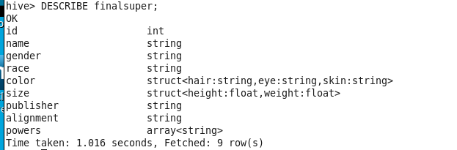

Then insert all the data from the superheros2 and superpowers2 to finalsuper table:

Terminal Command: INSERT INTO TABLE finalsuper SELECT superheros2.*, superpowers2.powers FROM superheros2 JOIN superpowers2 ON superheros2.name = superpowers2.name;

A screenshot of a cell phone

Description generated with very high confidence

10 Intuitive Questions

1. select name from finalsuper where gender='Male';

A close up of a logo

Description generated with very high confidence

2. select name from finalsuper where color.eye ='brown';

A close up of a logo

Description generated with very high confidence

3. select count(publisher) from finalsuper;

A screenshot of a cell phone

Description generated with very high confidence

4. select name from finalsuper where race = 'Human' AND color.hair = 'No Hair';

A screenshot of a cell phone

Description generated with high confidence

5. select name from finalsuper where race = 'Human' AND color.hair = 'No Hair';

A screenshot of a cell phone

Description generated with very high confidence

6. select powers from finalsuper where name = 'Abraxas';



7. select max(Alignment) from finalsuper;

A screenshot of a cell phone

Description generated with very high confidence

8 . select name from finalsuper where race = 'Human'and size.weight < 0;

A close up of a logo

Description generated with very high confidence

9. select name from finalsuper where size.height between 0 and 100;

A screenshot of a cell phone

Description generated with very high confidence

10. select count(gender) from finalsuper where gender = 'Female' AND (alignment = 'good' OR alignment = 'bad');

A screenshot of a cell phone

Description generated with very high confidence

Part 2: SOLR USECASE

First check if there solr on the VR:

Terminal Command: solrctl

A picture containing animal

Description generated with high confidence

Then generate the configuration for the lab2:

Terminal Command: solrctl instancedir --generate $HOME/configurationLab2

A close up of a logo

Description generated with high confidence

You can check your cloudera file see if the file is generated

A screenshot of a cell phone

Description generated with very high confidence

We done with the terminal you can close it, now follow this steps to open schema on your Cloudera VM

Go to cloudera's home -> configurationLab2 -> conf -> open schema.xml with gedit

A screenshot of a cell phone

Description generated with very high confidence

Then Copy and Paste the Schema include in Lab2 part 2 folder. This folder we created our own fields and we create our own uniqueKey

A screenshot of a cell phone

Description generated with very high confidence

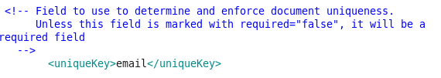

After Copy and Paste the scheme, safe the file and open new terminal and create lab2 file inside of configurationLab2

Terminal Command: solrctl instancedir --create lab2 $HOME/configurationLab2

A screenshot of a cell phone

Description generated with very high confidence

Then create collection called lab2

Terminal Command: solrctl collection --create lab2

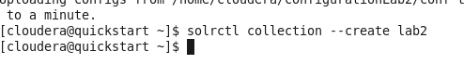

Then close to terminal and open web browser and type the link below:

Link: <http://quickstart.cloudera:8983/solr/#/>

A screenshot of a cell phone

Description generated with very high confidence

then go to thread and select lab2 and then go to documents -> then go to document type CSV and copy past the document then submit document

A screenshot of a cell phone

Description generated with very high confidence

Then Copy and paste the csv document that include in the lab2 -> Part 2

A screenshot of a social media post

Description generated with very high confidence

This was end of the Part A of the Part 2 of Lab2, for the Part B of the Lab2 click on Query and perform 10 intuitive question in database

5 Nested Queries and QTime for Each

1. state:LA AND _query_:"city: New Orleans" "QTime": 406

A screenshot of a cell phone

Description generated with very high confidence

2. city:"New York" AND _query_:"company_name:*inc" "QTime": 319

A screenshot of a cell phone

Description generated with very high confidence

3. first_name:Jo* AND _query_:"state:CA" "QTime": 34

A screenshot of a cell phone

Description generated with very high confidence

4. city:Abilene AND _query_:"state:KS OR state:TX" "QTime": 6

A screenshot of a social media post

Description generated with very high confidence

5. city:Baltimore AND _query_:"zip:2121*" "QTime": 6

A screenshot of a cell phone

Description generated with very high confidence

5 Nested Queries and QTime for Each

1. -email:*.com "QTime": 247

A screenshot of a cell phone

Description generated with very high confidence

2. phone1:913-* OR phone2:913-* "QTime": 10

A screenshot of a cell phone

Description generated with very high confidence

3. address:*st "QTime": 36

A screenshot of a cell phone

Description generated with very high confidence

4. first_name:Dalene "QTime": 2

A screenshot of a cell phone

Description generated with very high confidence

5. city:Abilene "QTime": 1

A screenshot of a social media post

Description generated with very high confidence